Mini Project: Quadcopter

Callum Owen-Bridge 15002504

**Appendix**

|  |  |
| --- | --- |
| ***Report Sections*** | ***Page Number*** |
| Introduction | 3 |
| Equipment | 3 |
| Procedure | 4-10 |
| Results page | 11-12 |
| How it Works | 13-15 |
| Uses and Issues of Quadcopters | 16 |
| Conclusion page | 17 |
| References | 18 |

**Introduction:**

The aim of this project is to build a quadcopter in X configuration, to gain understanding of how a quadcopter works and identify its uses and issues. This build will be a basic quadcopter, as it cannot pilot itself or have the ability to remain in flight without being controlled by the user. However, the quad copter can be adapted to be controlled by an Arduino. The design and build of this quadcopter will be researched, however any websites used will be used mainly to find the parts needed to build a quadcopter and how to set it up, (Posted (2012)). The quadcopter will be then tested to see how it operates. The quadcopter will be built and tested. Then research will be carried out to find more information on the quadcopter, such as its uses and any issues.

**Equipment and Materials:**

* TurnigyH.A.L. (Heavy Aerial Lift) Quadcopter Frame 585mm
* Hobbyking KK2.1 Multi-rotor LCD Flight Control Board
* Four D2830-11 1000kv Brushless Motor
* GWS Style Slowfly Propeller (clockwise) 9x4.7
* HobbyKing SlowFly Propeller (counter-clockwise) 9x4.7
* Four Turnigy Multistar 30Amp Multi-roto Brushless ESC 2-4S
* ZIPPY Compact 4000mAh 3S 25C Lipo Pack
* HXT 4mm 4X3.5mm bullet multistar esc power breakout cable
* Turnigy Battery Strap 330mm
* Male to male servo lead (JR) 26AWG 20cm
* Hobby King 2.4GHz 4 Channel Tx&Rx V2 (Mode2)
* Zip ties
* Bench power supply

**Procedure**

The procedure and parts list has been noted from a website, Posted (2012). All the parts were laid out on a table. Before the quadcopter was built the battery was plugged into its charger until it was fully charged, to do this a power supply or 12V battery is needed to operate the charger. The frame was put together using the included tools, however the screws which used locking nuts were left loose so the frame can be taken apart for wiring management. The quad copter’s landing gear was attached to the frame depending on the configuration that was chosen for example for the X configuration the landing gear skids have to be perpendicular to the forward direction. The 4 motors were then attached to the frame arms, however the frame arms were turned round due to the type of screws used to fix the motors to the arm; the propellers were not added to the motors until the flight test, to prevent any injuries during setup stages. The battery’s strap was threaded through the landing gear as shown in the picture below. The flight control board was then attached to the centre of frame using the plastic screws provide, its position was determined by having the white arrow on the board point between two of the motor arms. The ESC breakout cable was threaded through the frame from the bottom, and a black and red cable was tied, using zip ties, to each point where there was an arm with a motor attached, (shown in the images below).

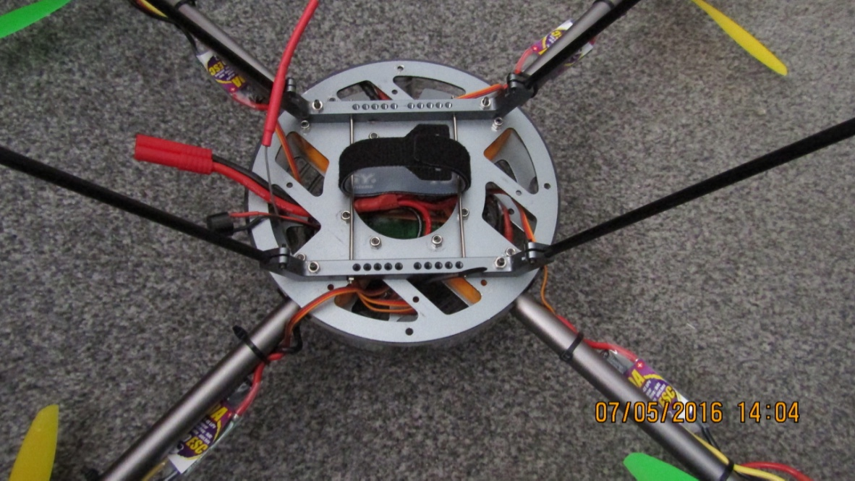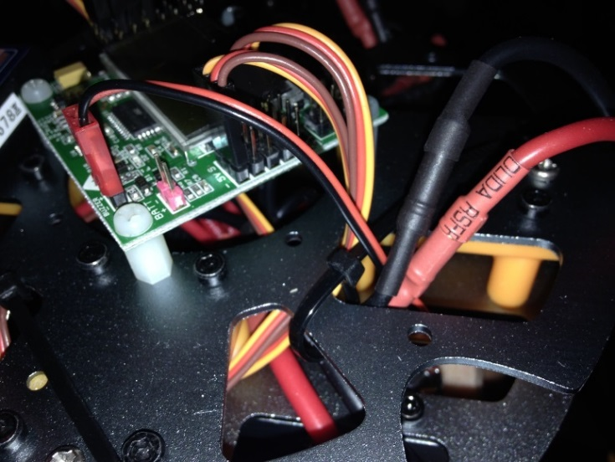

This image shows where the ESC power breakout cable is positioned within the frame, how the landing gear has been fitted and how the battery strap has been attached.

This image shows how the flight controlled board is fastened down and where it is positioned on the frame.

This image shows how the ESC power cables, of the breakout cable, were tied to the top part of the frame and where they are positioned.

An ESC was then placed onto each motor arm with the label facing down, this allows the ESC to dissipate heat as the unlabelled side of the ESC contains a heatsink and placing the ESC on top of the arm prevents it from being damaged, shown in the image below. The ESCs were then connected to each motor and attached to the power cable that is tied onto the frame, and its cables were tied to the frame arm to prevent the ESC moving during flight. The cables from the ESC to the motor were first connected in the correct order, for example red to red yellow to yellow and black to black, until flight testing. Any two of these wires can be swapped to change the direction of the motor, for example from clockwise rotation to counter clockwise rotation.

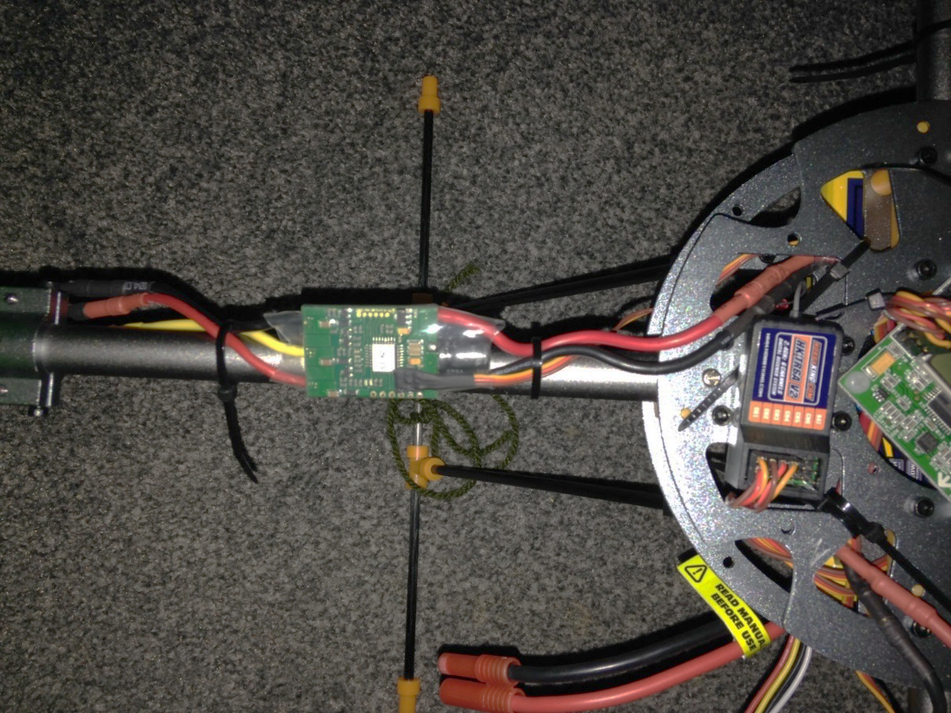

Power cables

Motor cables

This image shows where the ESC is positioned on the frame, how its cables are tied down and attached to the power and motor cables.

The ESC signal cable is threaded through the bottom of the frame and up to the flight control board, where they are attached to the pins to the right of the board, in order from motor one, plugged into the top row of pins, to motor four plugged into the bottom row of pins; motor one is the top left motor, motor two is the top right motor, motor three is the bottom left motor and motor four is the bottom right motor, this is found by looking for the white arrow on the flight control board which shows the forward direction of the drone. The signal cable of the ESC is made up of three wires the brown cable is ground, the red cable is for power and the yellow cable provides the signal. Due to the ESCs having a BEC (battery eliminating circuit), they can provide power to the flight control board. The outer column of the motor pins of the flight control board is for power, the middle pins is ground and inner pins is for the signals. This type of ESC doesn’t need to be programmed or flashed as it already comes pre-installed with software.

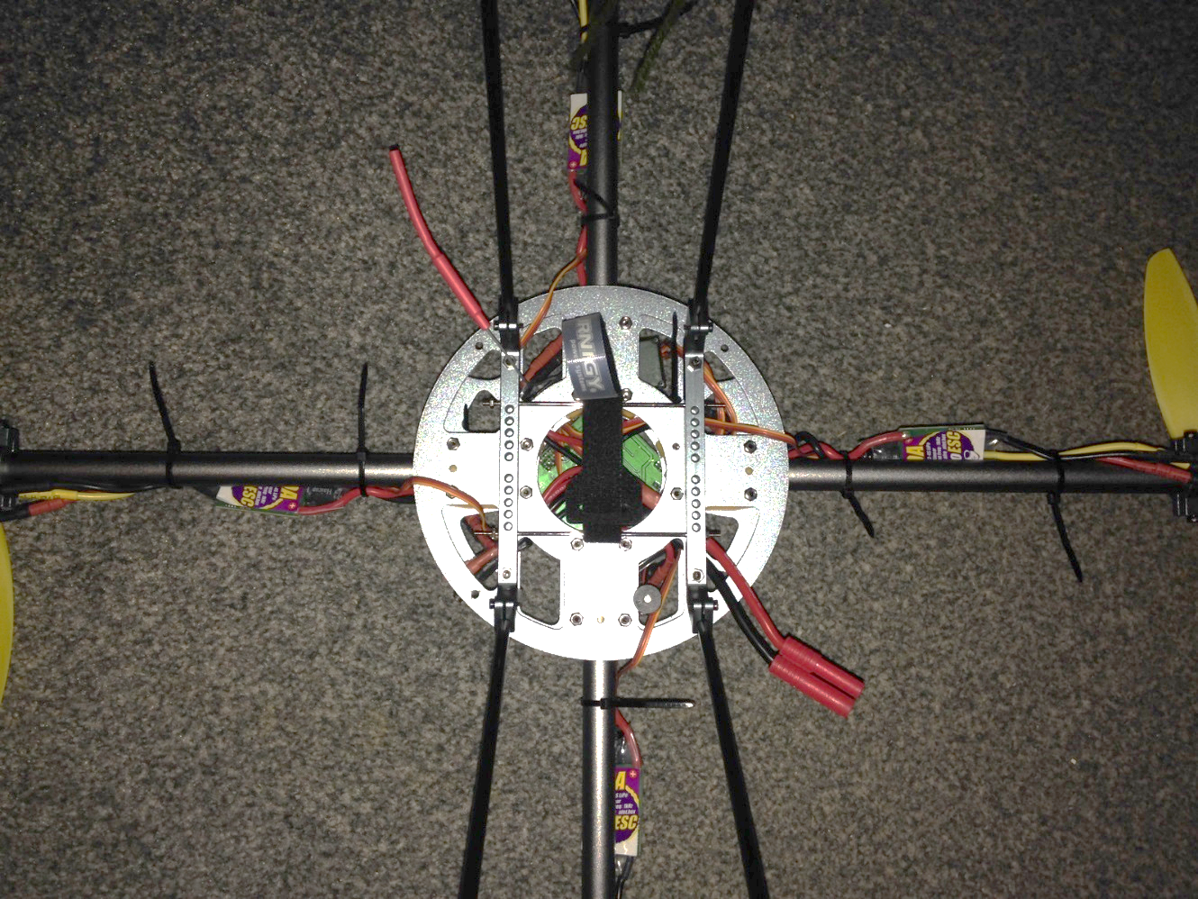

Motor:

1 2 3 4

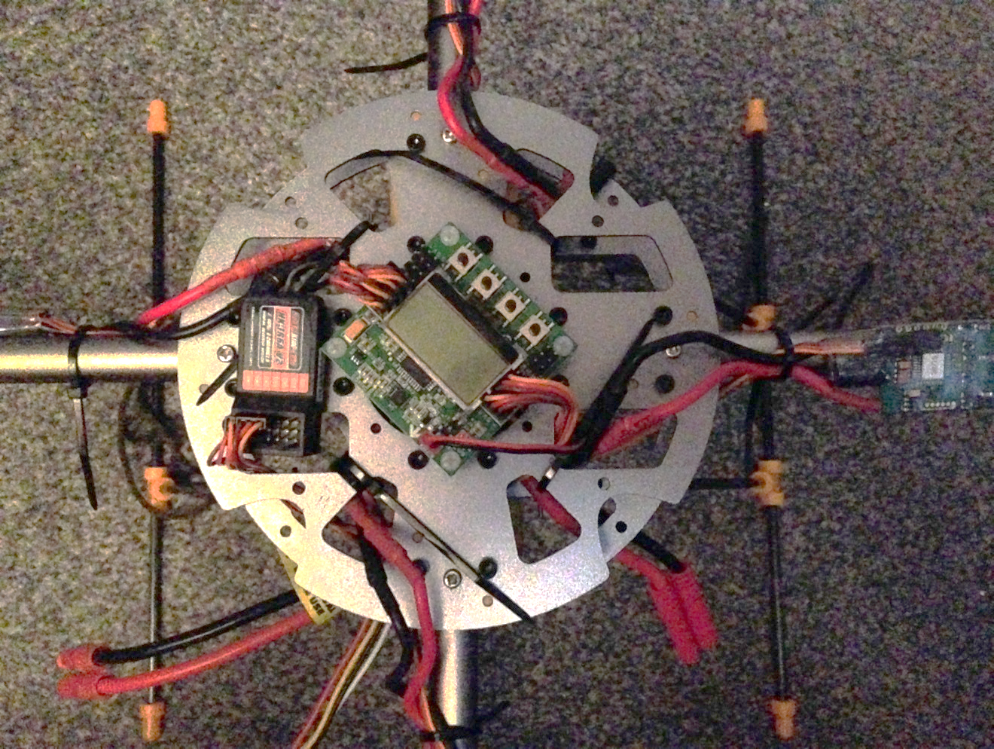

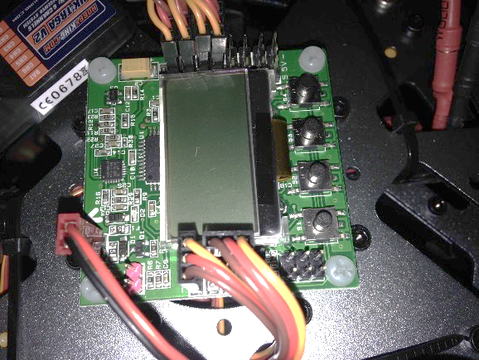

This image shows the arrow on the flight control board. frame, how its cables are tied down and where they are threaded through the frame

This image shows the ESC signal cable attached to the flight control board and how the pins are numbered.

This image shows how the ESC signal cable is threaded through the frame

The radio receiver was then attached to the flight control board’s pins to the left of the buttons, using the 20cm Male to male servo leads. One lead is attached to the first column of pins on the receiver labelled CH2 (brown cable, aileron), CH3 (red cable, throttle) and CH4 (yellow cable, rudder), these wires are attached to the signal pins of the receiver. The second lead is attached to the three pins labelled CH1, the cable attached to the pins CH1 provides the power and ground of the receiver; the brown wire is ground and the red wire is for power and the yellow wire is for the signals. The receiver’s binding lead was also attached to the pins labelled BAT and the receiver’s aerial was then threaded through the frame to the bottom.

The flight control board’s sound module was then attached to the pins labelled Buzzer on the flight control board, this provides sound for the board when pressing board buttons or to indicate different phases the board enters.

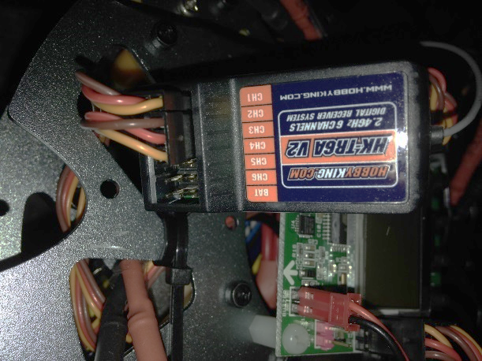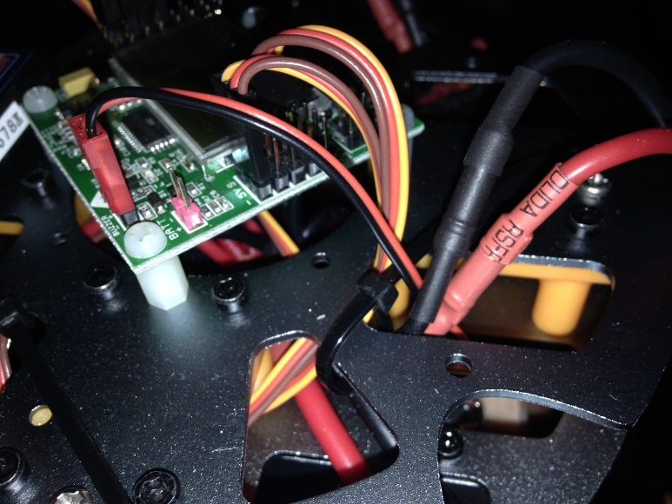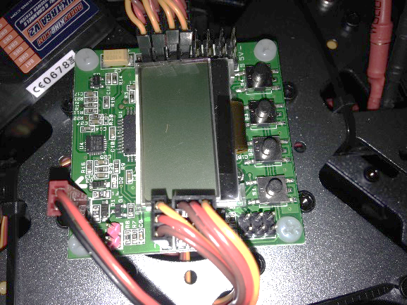

AIL ELE THR RUD

This image shows how the leads are attached to the receiver, the binding lead is attached to the top three pins labeled BAT.

This image shows the buzzer lead connected to the pins labeled buzzer.

This image shows the leads from the receiver attached to the flight control board, the lead attached to CH1 is attached to the aileron Pins, the top three pins. The lead attached to CH2, CH3 and CH4 are attached to the elevator, throttle and rudder pins; the inner column of pins.

Once all the components were connected except the propellers, the controller was turned on and the battery was plugged in to the connection on the ESC breakout cable. All the ESCs beeped and a green LED turned on indicating they are working. On the flight control board the LCD screen indicates that it is in safe mode, which means the motors shouldn’t move if the throttle stick was not in idle. The following stages are how the quadcopter was setup.

**Stage 1: Radio Binding**

The receiver’s binding cable is inserted into the pins labelled BAT, the battery is plugged into the breakout cable. The receiver had a blinking red light; this indicated that the controller hasn’t been bonded or is not connected. The transmitter or radio controller is switched on, and the bind range test button was held down. The light of the receiver became solid; this indicated the controller has been bonded. To make sure this bond has been made correctly, the battery was unplugged and before plugging the battery back in the transmitter must be turned on, the battery was then plugged back in and the light of the receiver should remain solid.

**Stage 2: Receiver Test**

To test the receiver was receiving signals from the controller, the receiver test option in the menu was selected. Here the values for aileron, elevator, throttle and rudder can be observed. For the aileron when the right stick is pushed left, left will be displayed next to the value, when pushed right, right will be displayed next to the value, this was correct and so the switch was kept at normal on the controller. For the elevator when the right stick is pushed up, forward will be displayed next to the value and when it’s pulled down, back will be displayed next to the value, this was correct and so the switch was kept at normal. For throttle when the left stick is all the way down the value should show zero and idle, however this was inverted so the switch on the controller for throttle was set to reverse. For the rudder when the left stick is moved left the value should be positive and display left and when moved right the value should be negative and display right, this was correct and so the switch was kept at normal. If the idle values for aileron, elevator, and rudder have a word displayed next to them the trim on the controller was adjusted, shown in the image below.

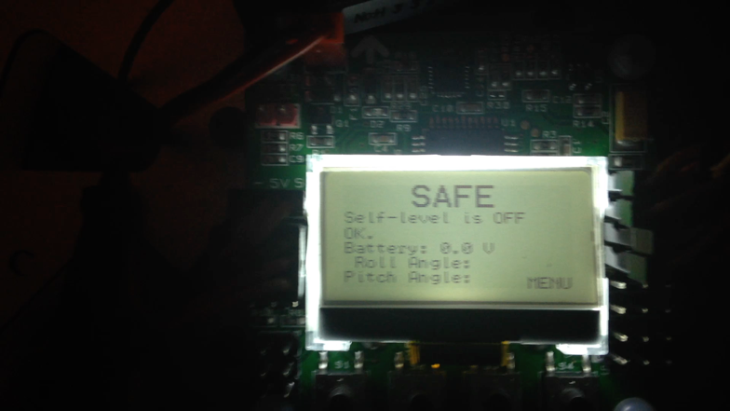**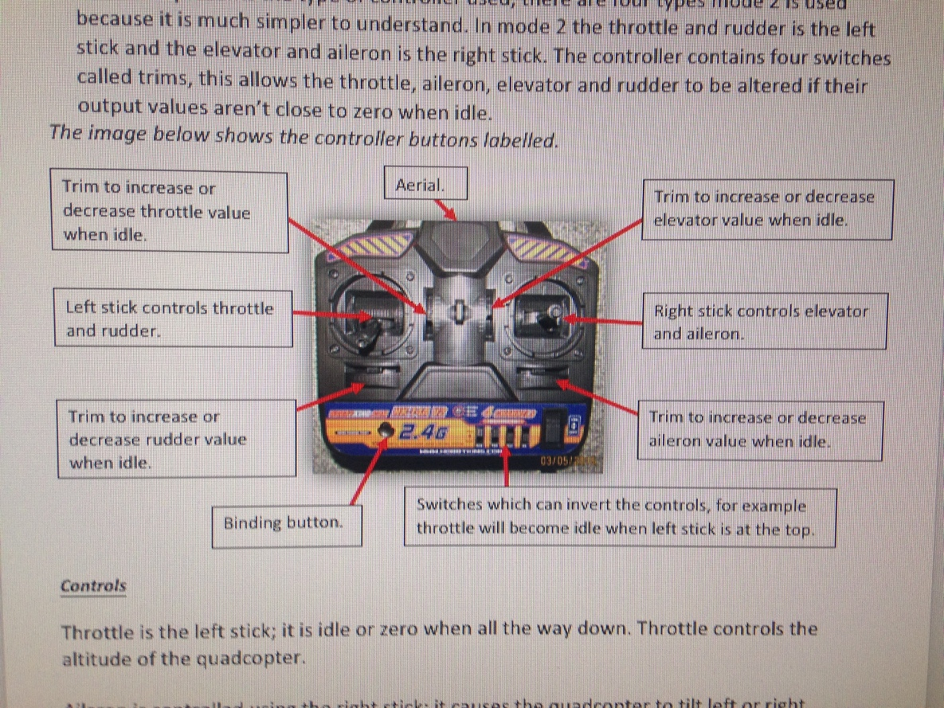*Below is a clip showing the receiver test and how it is displayed.***

**Stage 3: Sensor Test**

Before this test was started the props were not attached to prevent any injuries. The battery was plugged in and the buttons on the flight control board was used to enter the menu and move down to option called Sensor Test. This was selected and the display shown OK for the sensors, this indicated the sensors were working.

***Below is a clip showing the sensor test and how it is displayed.***

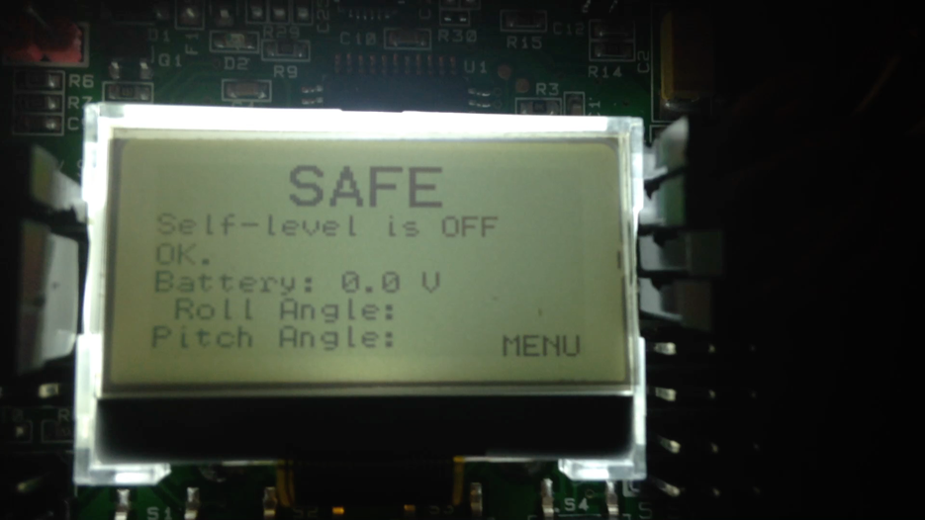

**Stage 4: Sensor Calibration**

For this test the quadcopter was placed on a level surface, the buttons on the flight control board were used to enter the menu and ACC calibration was selected. This ensures that the sensors are set to zero when level, so that when in-flight the quadcopter is more controlled and is able to self-level.

***Below is a clip showing the sensor calibration and how it is displayed.***

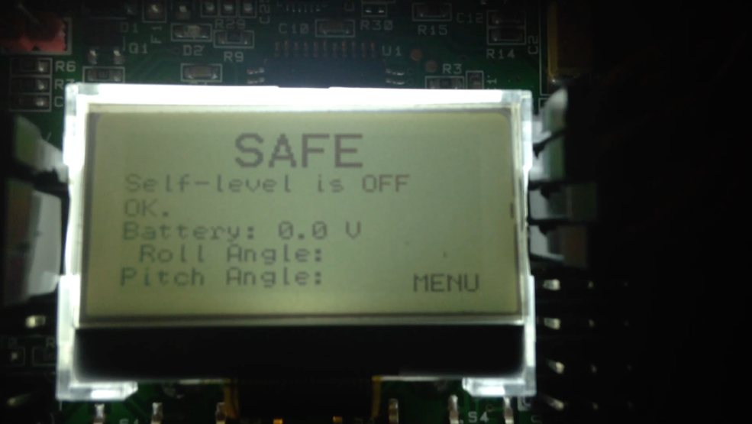

**Stage 5: Motor Layout**

The menu was navigated using the buttons and motor layout was selected. Quadcopter X was then selected from the options. This then displayed the motor rotation direction.

**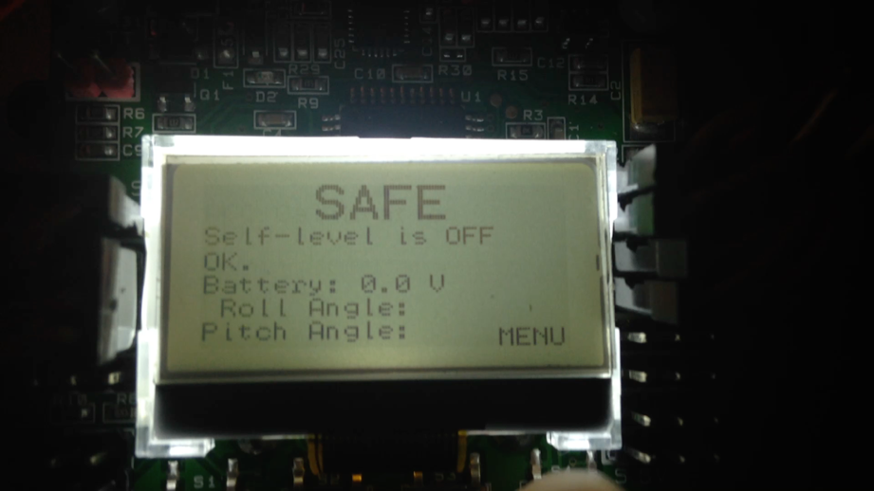*Below is a clip showing the motor layout selection process.***

**Stage 6: ESC Calibration**

Before this test was started the propellers were not attached to prevent injuries. The battery was unplugged and the transmitter was turned on and its left stick pushed up and centre, this is the throttle. The battery was then plugged in whilst the buttons one and four on the flight control board were held down. The throttle was then reduced until idle; left stick all the way down and centre. The ESCs made a long beep indicating they are calibrated. The calibration was then tested by arming the quadcopter, this is done by pushing the left stick of the transmitter down and right, a long beep was heard from the flight control board and ARMED was displayed on the flight control board. The throttle was then slowly increased to observe the motor movement. The quadcopter was then put into safe mode by pulling the throttle stick down and left.

**Stage 7: Flight Test**

Before the battery was plugged in the area chosen to do the test must be clear of any wild life, people or trees and must be a large space, this is to prevent any accidents from happening. The battery was unplugged before the propellers were added to the motors. The clockwise propellers were added to motors one and four, and the counter clockwise propellers were added to motors two and three. The quadcopter was then armed, self-level mode was turned on, by holding the right stick right whilst arming or by holding the right stick right whilst disarming the LCD display will then show self-level on. Slight throttle was added to test the direction of the motors, if any motor was turning in the wrong direction, the quadcopter was put into safe mode and the battery was unplugged. Then any two phase wires of the motor were then swapped for example black and red, as this changes the rotation of the motor. The movements of the quadcopter were observed, if the movements of the quadcopter were not as expected the flight controller will then be tuned shown in the next stage.

**Stage 8: Tuning the Flight Controller.**

To tune the quadcopter, the PI Editor was selected in the menu. The P-gain of Roll/Pitch was altered to 80 and I-gain was altered to 60, in YAW the P-gain was altered to 60 and the I-gain was altered to 60. The quadcopter’s flight was then tested, if the rotation was too fast or the quadcopter started to climb then the YAW gains was reduced, if the quadcopter started to move in a direction by itself or the quadcopter started to climb when the aileron stick was moved then the Roll/Pitch gains was reduced.

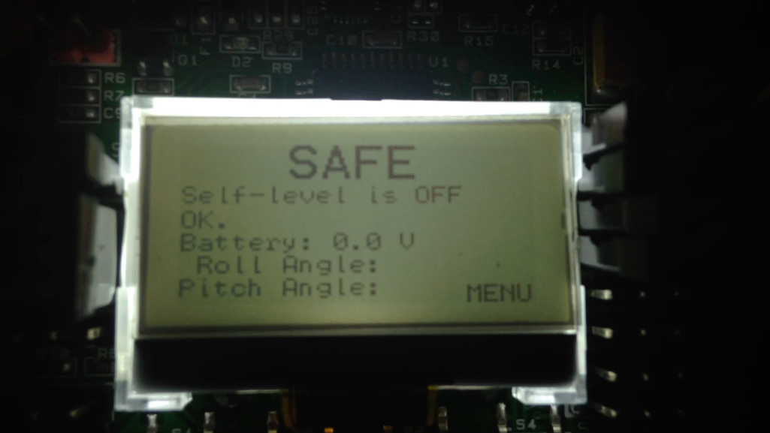

**Results**

On the first flight of the quad copter, it wouldn’t lift from the ground, but would only tilt left or right but, this was solved by swapping two of the phase wires of the counter clockwise motors.

During the first flight test the quadcopter started to drift to one side and in some cases flipped over, however this was solved by tuning the flight control board and turning self-level mode on.

There is an issue with the controller not connecting to the receiver but this was due to the disconnection between the receiver and controller. If the controller is turned off whilst the quadcopter was on. However, the solution to this was to not turn the controller off whilst the quadcopter is on, this prevented any lost connection from occurring.

When charging the battery using a DC bench power supply to provide power to the battery charger there was an issue as the charger would display low DC input however, this was solved by setting the voltage output to 12V and current to 1A.

The forward direction of the quadcopter was not clearly shown so the front propellers were marked to show its forward direction, shown in the image below.

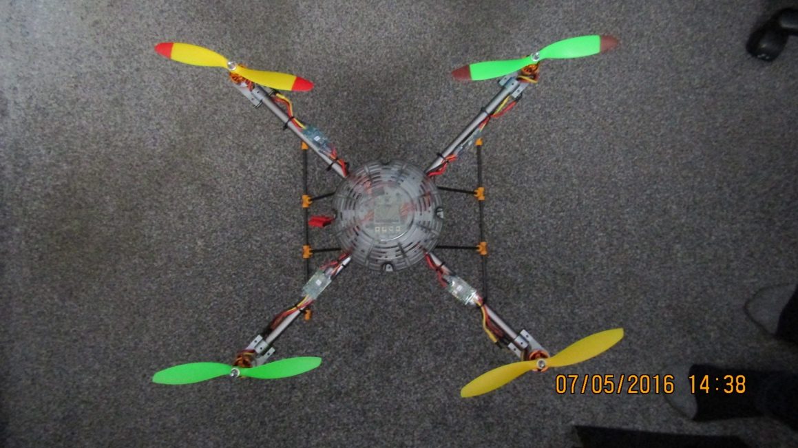

Once all the alterations were made the quadcopter was able to fly stably. On the next page are clips of the quadcopter flights.

***Below is a clip of the first quadcopter flight.***

The issue with this flight was that the quadcopter was not placed onto a level surface and was in an enclosed area. During the flight the throttle was slowly increased to observe the quadcopters movement, however due to the drifting the quadcopter flipped.

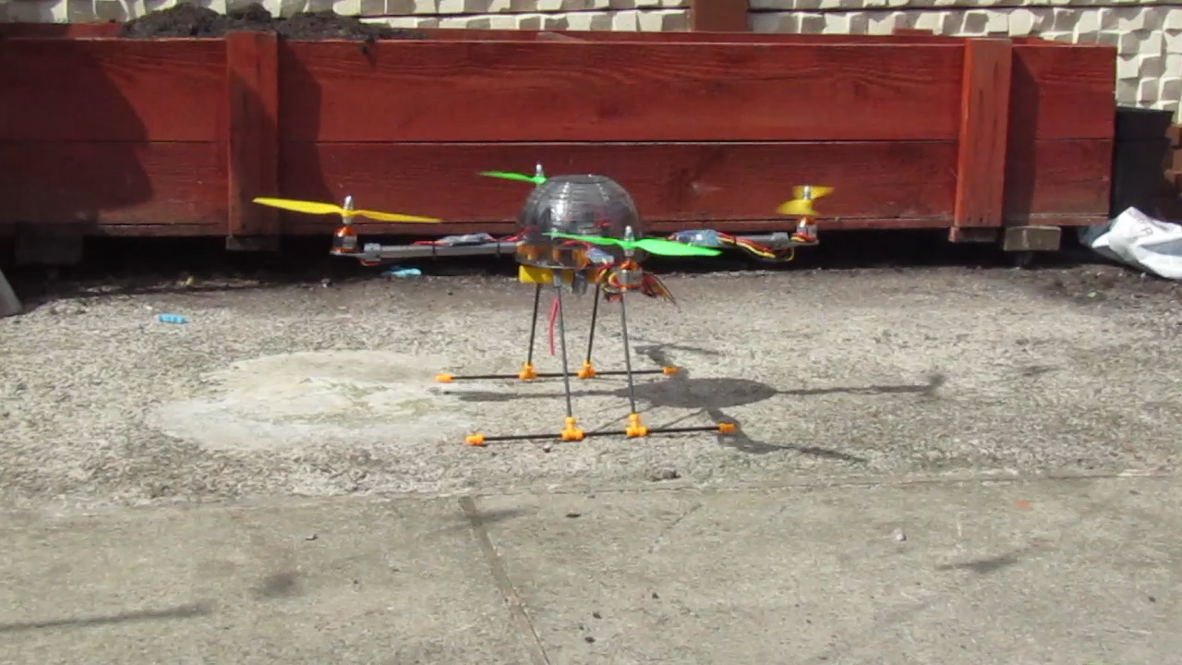

***Below is a clip of the quadcopter flight after the alterations were made.***

The issue with this flight was that the gain adjustments for roll/pitch were too high, therefore the quadcopter was tilting to the right.

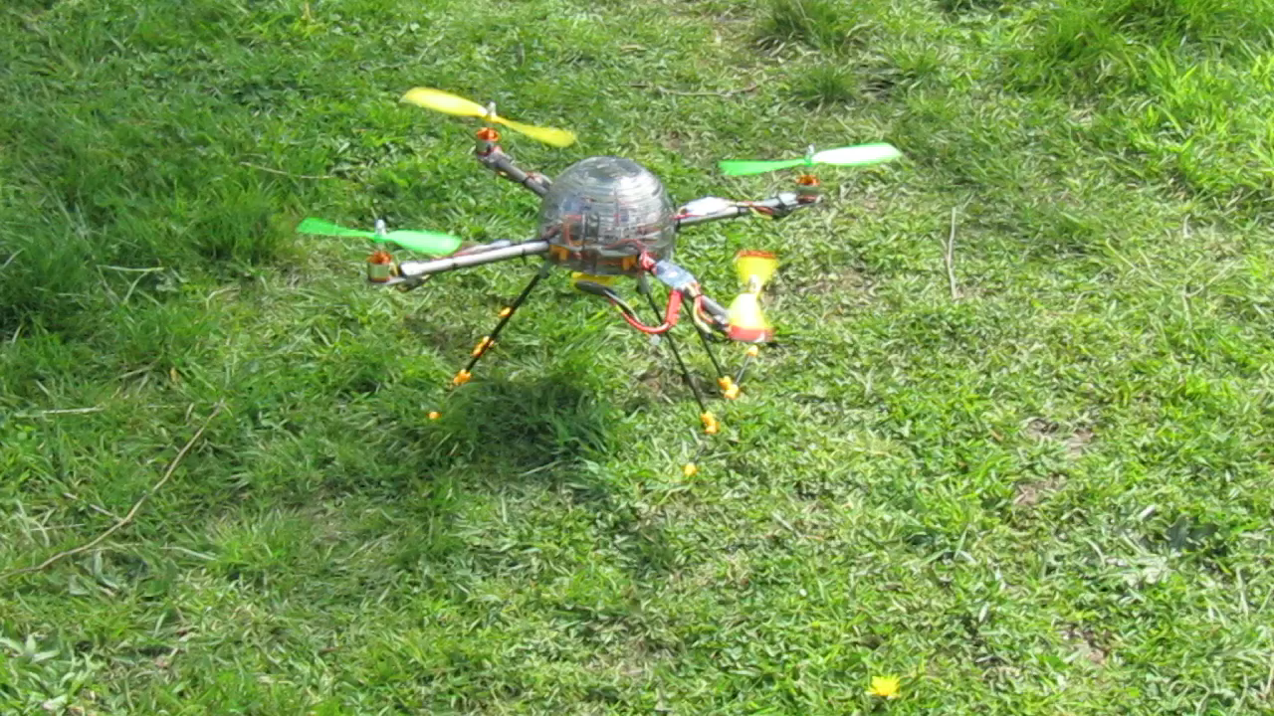

**How it Works**

This quadcopter build is made up of seven main components:

* A frame which can be any size, shape and made from different materials such as metal. Carbon fibre or plastic.
* A radio controller and receiver. The controller used is a six channel controller in mode 2. Mode 2 represents the controller layout used, there are four types, and this is used because it is much simpler to understand. In mode 2 the throttle and rudder is the left stick and the elevator and aileron is the right stick. The controller contains four switches called trims, this allows the throttle, aileron, elevator and rudder to be altered if their output values aren’t close to zero when idle.

*The image below shows the controller buttons labelled.*

Aerial.

Trim to increase or decrease throttle value when idle.

Trim to increase or decrease elevator value when idle.

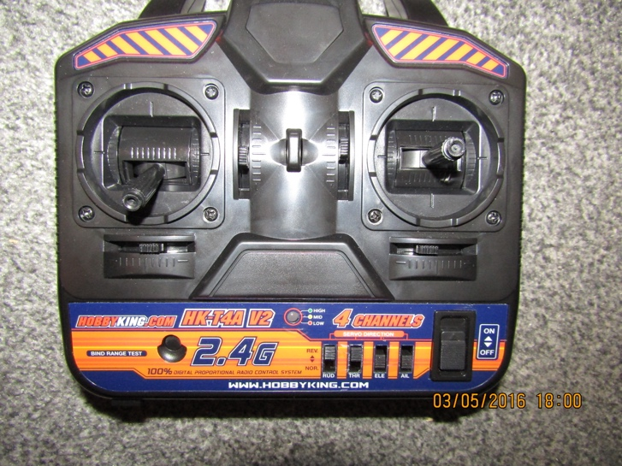

Right stick controls elevator and aileron.

Left stick controls throttle and rudder.

Trim to increase or decrease aileron value when idle.

Trim to increase or decrease rudder value when idle.

Switches which can invert the controls, for example throttle will become idle when left stick is at the top.

Binding button.

**Controls**

Throttle is the left stick; it is idle or zero when all the way down. Throttle controls the altitude of the quadcopter.

Aileron is controlled using the right stick; it causes the quadcopter to tilt left or right without rotating by altering the roll value. The stick can be moved left or right.

Elevator is controlled by the right stick; this causes the quadcopter to tilt forward or backwards by altering its pitch. The stick can be moved up or down.

Rudder is controlled by the left stick; this alters the yaw and causes the quadcopter to rotate left or right when the stick is pushed left or right.

* A flight control board, which receives signals from the radio receiver and uses the signals to determine the movement of the quadcopter. The flight controller does this by sending signals to the ESCs which alter the motor speeds. The flight control board can enter two phases safe mode and armed. Safe mode prevents the motors from turning on unexpectedly, this allows the user to be able to transport the quadcopter. Armed mode is when the motors are able to operate and the quadcopter can fly. The flight control board contains sensors which helps it to self-level during flight, due to the on board accelerometer and gyroscopes.
* Four ESCs which are electronic speed controllers. These components control the motors speed. An ESC contains four cables on one side and two power cables on the other, three of the four cables are used to control the motor and the forth cable is attached to the flight control board for signal transfer. There are two types of ESCs one type contains a system called BEC which is a battery eliminating circuit, this provides power for the flight control board, the other type is an OPTO ESC which doesn’t contain the BEC, however to use OPTO ESCs at least one ESC containing a BEC is needed.
* A Lithium ion polymer battery. This is used as it provides a high energy storage to weight ratio, so providing longer flight time. This battery is quite powerful but is also dangerous, if the battery isn’t charged correctly it can could explode.
* Counter clockwise and clock wise propellers. The clockwise propellers provides the lift for the quadcopter and the counter clockwise are normal propellers which would allow the quadcopter to change its movement. The propellers are made out of plastic, however they can be made out of other materials such as carbon fibre which are much stronger. Propellers used are determined by its pitch, length and motor Kv. If the motor Kv is low then a greater length propeller can be used and propeller pitch. The propeller used is 9x4.7”, so it has a length of 9 inches, the greater the length the less efficient the propeller will be and will draw more current. The propeller has a pitch of 4.7, the greater the pitch the more weight that the quadcopter can carry, the lower the pitch the more stable the quadcopter will be. For copters used for filming a hexacopter or octocopter is used with smaller propellers as this draws less current providing longer flight time and more stability for filming.
* Four brushless motors. Brushless motors are used as they have a longer life expectancy, they cool down quicker and don’t produce as much noise compared to brush motors. These motors contain a permanent magnet on the outside called the rotor and a rotating core made up of three coils called a stator, the coil forms an electromagnet field when powered, each coil is attached to a phase wire for example one coil for yellow, one for black and one for red. When a coil is powered it forms an electromagnet field and its poles becomes attracted to the poles of the rotor and so rotates the rotor, as the stator approaches the magnet poles the next coil is powered on and this is repeated rotating the rotor. The direction of the motor is changed by swapping the phase wires round because this changes the order in which the coils are turned on. The motors have a Kv rating which is value which refers to the number of revolutions per minute when one volt is applied. To determine which motor to use the weight of the quadcopter must be found and then the thrust of each motor. The required thrust per motor is the half the weight, this allows the quadcopter to fly around 50% of the throttle this can allow the motors to gain more power for stabilising the quadcopter.

Rotor containing permanent magnets.

Stator containing the coils.

This image shows how a brushless motor works, however the motor in the picture is a different type to the one used in the quadcopter.

***Different types of copter configurations***

There are different configurations of a copter, as they can have one to eight motors and form different formations such as VTail or Y6 or X8 and they all have their own advantages and disadvantages, (Liang, O. and Vaszary, Z. (2015)).

For a quadcopter there are two configurations “X” or “+”. The X configuration is mainly used for photography or filming as this is more stable and keeps the propellers out of view of the camera. The + configuration is used for sport flying as it is easier to fly and its orientation can be found easily.

The VTail copter contains four motors in a Y formation but its back two motors I slightly tilted forming a V shape.

An Y6 copter is a copter with six motors in Y formation but with two motors at each point per arm, so one motor above and another below. An X copter has eight motors in X configuration and two motors at each point, so one motor above and another below. Having dual motors allows the copter to be more compact and have similar lifting capabilities to a hexacopter or octocopter, however the disadvantage of these is that the bottom motor can get caught on objects and can be in view of the camera.

**Uses and Issues of Quadcopters**

The quadcopter has many uses, for example at the moment many film production studios use them for filming and photography as they can fly at high altitudes, they can remain quite stable when airborne and are more cost effective than using helicopters. Delivery companies are using copters to deliver packages.

Quadcopters can be used to surveillance an area for security, for example police and military are using them to search areas and buildings before entering them as this prevents the risk to human life and if small quadcopters are used they can be quite quiet. Quadcopters can be used to observe how the area is changing such as in agriculture or floods.

There are autonomous quadcopters, this means the quadcopter can move independently without any control. This allows the quadcopter to fly to specific areas such as delivering packages or to follow objects. For example, a quadcopter called AirDog has the ability to film and follow a person autonomously and is able to adapt different terrains such as high winds due to the many sensors it contains, (Prindle, D. (2016)).

The issues with quadcopters are that they can be very dangerous. The propellers are exposed and spin at a high speed, so they can cause harmful injuries or can damage objects. They could be carrying batteries such as lithium ion polymer which can explode. Due to these problems laws have been placed by many countries which restricts the use of these types of aircraft in certain areas and in some cases a license is needed to be able to fly them.

**Conclusion**

To conclude, the quadcopter was able to fly and I gained a good understanding of how it works, there were a few issues with flying tests but this was solved by adjusting the gains when tuning the flight control and board and keeping self-level on.

To improve on this build, an Arduino board or Raspberry PI would be added which would allow for the ability to code the quadcopter and add extra components such as GPS, so the drone can be tracked or autonomously fly to a position, a system could also be added to the landing gear which could drop objects such as a first aid kit.

There are many uses for quadcopters such as, filming and photography as they are very stable and more cost effective than using a helicopter, they are currently used in delivery services as they aren’t affected by traffic and don’t produce as much pollution as a vehicle. Quadcopters can be used to surveillance an area or to search an area for agricultural reasons or to see the effects of climate change.

However, there is an issue with owning and flying quadcopters due to there being no guards on the propellers, they can cause serious injuries if not controlled properly and due to the ability to add cameras they can invade privacy, so there is now a law which places many restrictions on copters and drones which is also preventing companies which use them to deliver packages from developing this section of their company.

For the future of quadcopters, they are being improved more and more every year as they become more compact, smaller and more complex such as AirDog. Soon there will be autonomous quadcopters flying every day for different purposes, they could help protect or aid people and could be used to help battle in wars.

***References:***

Bibliography

*, N. (2008) *How to fly a Quadcopter - the ultimate guide*. Available at: http://uavcoach.com/how-to-fly-a-quadcopter-guide/ (Accessed: 8 May 2016).

2016 (1996) *The new KK2 FC, info and Q&A in first post. Read it before asking a question*. Available at: http://www.rcgroups.com/forums/showthread.php?t=1675613 (Accessed: 7 May 2016).

Liang, O. and Vaszary, Z. (2015) *What you should know about Multicopter configurations*. Available at: http://www.dronethusiast.com/what-you-should-know-about-multicopter-configurations/ (Accessed: 8 May 2016).

Posted (2012) *Easy DIY Quadcopter build (part 1) – the parts list*. Available at: http://oddcopter.com/2012/12/12/easy-diy-quadcopter-build-part-1-the-parts-list/ (Accessed: 6 May 2016).

Prindle, D. (2016) *Getting chased through the desert by AirDog, the easiest drone to fly*. Available at: http://www.digitaltrends.com/cool-tech/airdog-auto-follow-drone-ces-2016-hands-on/ (Accessed: 10 May 2016).

Citations, Quotes & Annotations

*, N. (2008) *How to fly a Quadcopter - the ultimate guide*. Available at: http://uavcoach.com/how-to-fly-a-quadcopter-guide/ (Accessed: 8 May 2016).

(*, 2008)

2016 (1996) *The new KK2 FC, info and Q&A in first post. Read it before asking a question*. Available at: http://www.rcgroups.com/forums/showthread.php?t=1675613 (Accessed: 7 May 2016).

(2016, 1996)

Liang, O. and Vaszary, Z. (2015) *What you should know about Multicopter configurations*. Available at: http://www.dronethusiast.com/what-you-should-know-about-multicopter-configurations/ (Accessed: 8 May 2016).

(Liang and Vaszary, 2015)

Posted (2012) *Easy DIY Quadcopter build (part 1) – the parts list*. Available at: http://oddcopter.com/2012/12/12/easy-diy-quadcopter-build-part-1-the-parts-list/ (Accessed: 6 May 2016).

(Posted, 2012)

Prindle, D. (2016) *Getting chased through the desert by AirDog, the easiest drone to fly*. Available at: http://www.digitaltrends.com/cool-tech/airdog-auto-follow-drone-ces-2016-hands-on/ (Accessed: 10 May 2016).

(Prindle, 2016)